**Statements of Requirements**

**Version 1.2**

**Table of Contents**

**1. Preface 3**

**2. Issue 3**

**3. Customer’s Wishes 3**

**4. Task 5**

**5. Requirements 5**

**6. Information 5**

**7. Necessities 6**

**8. Access and Security 6**

**9. Functional Demands 6**

**10. User Interface 7**

**11. Objective 8**

**12 Technical Demands 8**

**13. Development Environment 8**

**14. System Demands 8**

**15. Sources 8**

# **1. Preface**

**1.1 Introduction**

You are working for the application and media development department of an IT company. This company is hired to develop a reservation website for **Hotel California**. The website will replace the full paper administration of the reservation desk.

**1.2 Hotel California**

The company is **Hotel California**. They are a Dutch hotel company that wants to improve their quality and make their customers leave with a big smile. Since they are still using full paper administration for reservations, they wanted to make it faster and easier for both customers and the hotel itself. The hotel keeper has been in the hotel business for 20 years and seen many hotels switch over to an automatic reserving method which has been a success most times.

**1.3 The Project**

This project will utilize various programming techniques, for example, PHP, JavaScript, CSS3/sass, SQL, HTML5, and OOP. I will have 10 weekends to finish this project and publish my live release.

**1.4 Target Audience**

The website will be primarily used for customers who want to stay at **Hotel California** for the night. Everyone above 18 years old is allowed to book and reserve a room to stay for the night.

**1.5 Others**

Children are **not allowed** in the hotel **unless they have their guardians** with them. This is for their safety.

# **2. Issue**

**2.1 What is the problem?**

The company is using full of paper administration when you want to reserve a room, which is not the ideal system in this period.

**2.2 How to solve the problem?**

To solve the problem they have come up with an idea to speed up the process by allowing customers to reserve their rooms via a website. Thus allowing **Hotel California** to allow keep track, manage, and add available rooms on their website to let their customers know.

# **3. Customer’s Wishes**

**3.1 What are the customer’s wishes?**

Your boss has interviewed the hotel staff, in order to record the hotelkeepers’ wishes. He also described the following 4 subsystems of the website and the functionalities therein:

1. **The room administration subsystem:**
   1. The hotelkeeper must be able to see a room plan with the location of the rooms.
   2. The hotelkeeper must be able to add the category of rooms available in the system.
   3. In the room plan, the hotelkeeper must be able to assign the category that the room belongs to.
   4. The hotelkeeper must be able to print a list of rooms and the category they belong to.
2. **The pricing subsystem:**
   1. The reservation desk must be able to assign a room price for one of the 3 categories of rooms (family, single, double rooms, luxury, etc.) for a certain day of the year. The pricing system must be filled in, at least 3 months in advance.
   2. The reservation desk must be able to retrieve a list of room prices per day. They must be able to print this list.
3. **The web reservation system:**
   1. Web visitors must be able to see the available categories of rooms and the prices for those categories from a certain start- to an end date. When the prices differ during the period, it is also shown on the website. Per room category the visitor will see some photos on the website and a video in an appropriate web format. The visitor will also see the number of rooms available per category.
   2. The web visitor must be able to make a reservation. While making the reservation the visitor must be able to enter his name, first name, home address, city, country, telephone number, and email address. After entering the reservation, the visitor will receive a confirmation email that will include the invoice.
   3. The hotelkeeper must be able to see and print a list of occupied and reserved rooms within a certain period.
4. **The front desk system:**
   1. The front desk must be able to print a list of room prices for a week.
   2. The front desk must be able to see all unoccupied and the amount of “not reserved” (vacant) rooms on a certain day per category.
   3. The front desk must be able to register a guest as an occupant of a room.
   4. The front desk must be able to see if the room is prepaid or post-paid.
   5. In the case of post-paid rooms, the front desk must be able to print an invoice for the room rent (fee) that is due.

**3.2 Tools**

To fulfill the customer’s wishes I will need the following tools, devices, or applications in my possession:

* **Device**: without a laptop or desktop computer I will not be able to produce an end product to the customer. I will be working on my laptop and desktop computer during this project.
* **Code Editor**: without a functioning code editor I cannot program to the minimum standards of coding. I will utilize Visual Studio Code as my code editor during this project.
* **Local server**: I will need a local server so I can test my web pages, fix bugs, optimize my product, and test PHP code. I will be using XAMPP during this project as my local server.
* **Database**: to store the data that can be retrieved from the website I will need to store it somewhere. I will use phpMyAdmin as my database.
* **Internet:** I will need an internet connection to get access to google to research for this project.

# **4. Task**

**4.1 What are my tasks?**

I have to complete the following task, which will not only help me improve but also give me insight into how an actual reservation/hotel website might look, how it will function, how the user interfaces works, and the most important how to build a solid and attractive e-commerce website in the future.

1. Research all data, information, and reports that are necessary for the system. You can investigate the functionality needed on the internet, for instance on expedia.com, hotels.com, booking.com, tripadvisor.com, and many more.
2. Create planning, to ensure that you can design, build, test, and implement each subsystem iteratively. (Choose your sequence of delivery!) You must be able to deliver a subsystem every fortnight. All subsystems must be up and running in week 9. Every 2 weeks you will be assessed on your design, build, testing, and implementation skills.
3. In week 10 you must give a presentation, in English, describing and clarifying the system. In this presentation, you will justify your design and build choices.

**4.2 Bonus assignments**

* Invoicing system for the minibar usage during a stay
* Ticket system for room service (chef and waiter)
* Connect room service tickets to the invoicing system
* Cleaning alert on the floor map at checkout
* Cleaning roster with the most efficient route

# **5. Requirements**

**5.1 What are the requirements?**

There are a few requirements that I have to follow during this project. The first one that the website **must be made in PHP**. The second one is that **I must use PDO** for the database connection. The third and last one is that it **must make use of OOP** (Object-orientated programming).

**5.2 Others**

I can make use of any javascript library, bootstrap, or full-page templates **IF** all the conditions have been met. The conditions include the customer’s wishes and project requirements.

# **6. Information**

**6.1 What information will be displayed on the website?**

On the website, there will be information about the company, a short description of who they are and their goals. There will be a staff list as well, which can help you assist with your problems regarding the website. Besides information about the company, there will be for each room a short description and price displayed. This will allow the customer to find the perfect room for his budget and personal preference. And lastly, there will be a contact information section, which if you have any questions regarding price and rooms will be answered on there.

**6.2 Others**

On the landing page, there will be a paragraph of text displayed. The main purpose of this text is to attract the customers and it will contribute to the design part.

# **7. Necessities**

**7.1 Hardware**

* Working laptop, notebook, or computer with Windows, Linux, or Mac OS.
* Dummy or a sketchbook to make on paper sketches and notes.

**7.2 Software**

* Microsoft Office or Google Docs for typing reports.
* Case tool for UML such as Visual Paradigm, UMLET, draw.io, etc.
* Text editor such as Notepad++ or Text wrangler to be able to type HTML5, CSS3, PHP and JavaScript codes.
* An IDE such as Eclipse or NetBeans.
* Internet browsers:
  + Firefox
  + Brave
  + Opera
  + Google Chrome
  + Safari
  + Microsoft Edge
* FTP program or plugin such as FileZilla or FireFTP to place files on the school server.
* XAMP, WAMP SERVER, MAMP, or similar MySQL | Apache | PHP package.

**7.3 Network**

* Access to the IDC-ICT network for internet access.
* Possibly a webspace on WEB5 to be able to publish web pages.

# **8. Access and Security**

**8.1 Who can access the website?**

The website can be accessed by **anyone**, however to reserve/book a room **MUST** have an existing account, or you can create a new one. The privileges of an existing member or new member are limited, it is **NOT** possible for them to make any changes to the website. However, with an admin account, it is possible to make changes to the websites. There will only be **1** admin account to decrease hacking possibility.

**8.2 What about security?**

To increase the security on the website each member will be tracked, the admin can see each individual member and what they are doing. When closing / leave the website the tracking will stop. All of the users’ actions will be stored in a **LOG.DAT** file. This also applies to the admin account.

# **9. Functional Demands**

**9.1 What are the functional requirements for the website?**

For the website to perform to the expectation of the customers all the links have to function. The images need to be properly loaded in and able to scale down or up depending on the users’ device he or she is using. Besides links and images working the **MOST** important part is; can you book a room on the website? If that part is not functioning correctly the customer’s wishes have not been met. There are also some minor things that need to function as well such as a responsive, payment system, creating an account, to logging as an existing user, and lastly to save all the data in the assigned database with the information needed.

# **10. User Interface**

**10.1 How will the user interface look?**

Down below you will see the wireframe for the landing page. Keep in mind this is **ONLY** a sketch of what the website might look like. The end product **WILL** differ towards a different design as a result of researching and optimizing the website to the customer’s wishes and the project requirements.

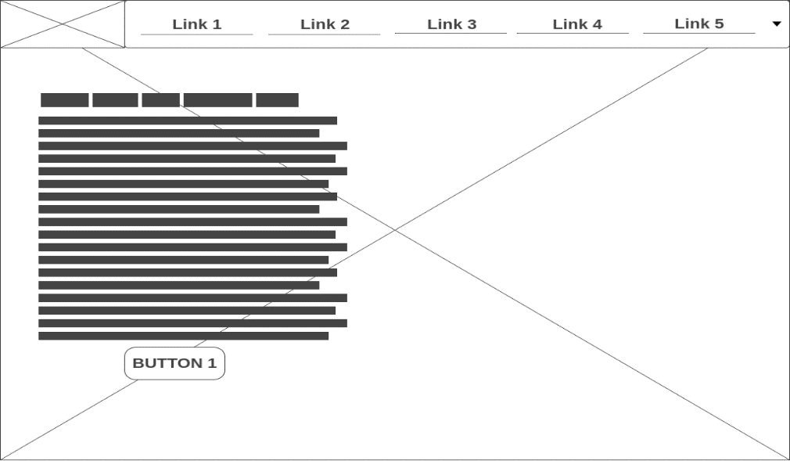

*Image 1: Landing page design.*

**10.2 Color scheme, font-family, images?**

For this project, I will be using a **black** and **white** color scheme in my design. This will allow me to create some fantastic designs for the audience I will target. As for the font family, I will be using a couple of google font; **Noto Sans JP [1]**, **Montserrat [2]**, and **Roboto [3]**. And lastly, I will use pexels [4] as my source for images.

**10.3 Inspiring Wireframes**

*Image 2: Design [5] Image 3: Design [6] Image 4: Design [7]*

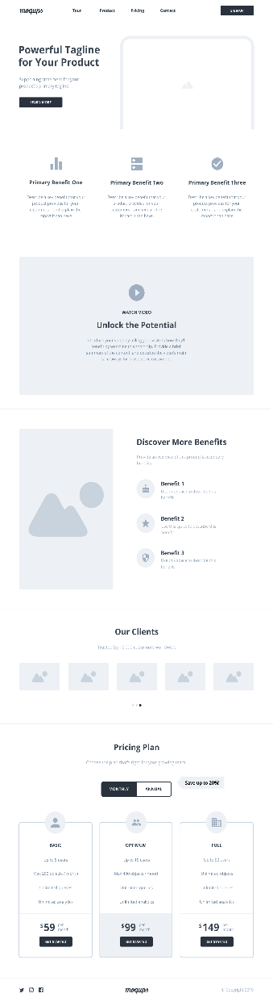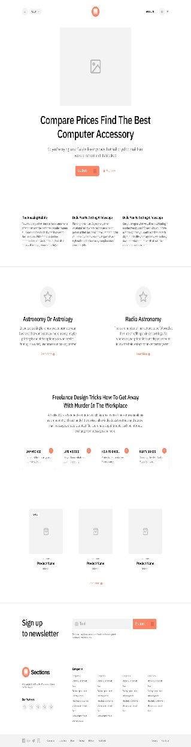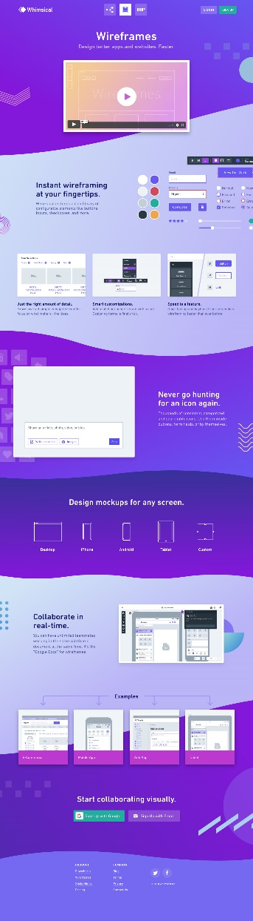

# **11. Objective**

**11.1 What is the main objective of this website?**

The main purpose of creating this website is to speed up the time it takes for each customer to book and pay for their room.

# **12 Technical Demands**

**12.1 What are the technical requirements for the website?**

The website **MUST** be made with PHP, OOP, and SQL which should use PDO. Using mySQLi is **NOT** allowed during this project.

**12.2 Database**

The database will be from XAMPP, which is MySQL. The database is very easy to use, has a strong performance, and a clean user interface.

# **13. Development Environment**

**13.1 My development environment**

I will be completing this project at home. I switch between my desktop computer and laptop as my workflow. Most of the time I am programming outside which will help me get more motivated and ideas.

**13.2 What do I use?**

As for my laptop is it an ASUS VivoBook S14 with Windows 10 v1909 installed as the OS. For my desktop computer, I am using a late 2014 iMac with macOS Catalina 10.15.4 installed as my OS. On both my devices I have Visual Studio Code installed. I am using the GIT client GitHub to synchronize my work into one repository which can be found online. [8]

# **14. System Demands**

**14.1 What are the minimum requirements for your system?**

For the reservation system to function correctly there have been a few conditions to be met regarding the users’ system. They are as following:

1. Operation System (OS):
   1. Windows 7/8/10 64-bit
   2. macOS Sierra or higher
   3. Linux
2. Random access memory (RAM):
   1. **ANY**
3. Central processing unit (CPU):
   1. **ANY**

# **15. Sources**

**15.1 Origin**

* Noto Sans JP [1]: <https://fonts.google.com/specimen/Noto+Sans+JP>
* Montseratt [2]: <https://fonts.google.com/specimen/Montserrat>
* Roboto [3]: <https://fonts.google.com/specimen/Roboto>
* Pexels [4]: [https://www.pexels.com](https://www.pexels.com/)
* Design [5]: <https://moqups.com/templates/wireframes-mockups/saas-landing-page/>
* Design [6]: <https://www.lapa.ninja/freebies/sections-landing-pages/>
* Design [7]: <https://www.lapa.ninja/post/whimsical-wireframes/>
* GitHub Repository: <https://github.com/junyi-xie/hotelcalifornia>

**15.2 Copyright**

© 2020 All Right Reserved. Document by Jun Yi Xie.

**Statement of Requirements created by Jun Yi Xie.**

**Version 1.2**